CS310 Data Structures Java Programming Assignment 2 Rubric

|  |  |  |  |  |
| --- | --- | --- | --- | --- |
| Java Program: |  | | | |
| Rating Rating Category | Exemplary | Partially Proficient | Basic (needs work) | Not Demonstrated |
| Donor Log  Implementation | The program correctly implemented the class and all required methods. | There are some minor errors in the required class. | There were major errors in the required class. | This class was implemented incorrectly, or not implemented at all. |
| Pts | 9 | 8 - 7 | 6 - 2 | 1 - 0 |
| Donation Log  Implementation | The program correctly implemented the class and all required methods. | There are some minor errors in the required class. | There were major errors in the required class. | This class was implemented incorrectly, or not implemented at all. |
| Pts | 9 | 8 - 7 | 6 - 2 | 1 - 0 |
| Print  Implementation | The program correctly implemented the class and the required method. Report formatted as specified. | There are some minor errors in the required class. | There were major errors in the required class. | This class was implemented incorrectly, or not implemented at all. |
| 5 Pts | 9 | 8 - 7 | 6 - 2 | 1 - 0 |
| Method to read and process data file | Implemented method correctly, as specified. | There are some minor errors in the method. | There were major errors in the method. | Few (or none) of the requirements for this method were implemented. |
| Pts | 9 | 8 - 7 | 6 - 2 | 1 - 0 |
| Method to process  Donor additions | Implemented method correctly, as specified. | There are some minor errors in the method. | There were major errors in the method. | Few (or none) of the requirements for this method were implemented. |
| Pts | 9 | 8 - 7 | 6 - 2 | 1 - 0 |
| Method to process  Donor deletions | Implemented method correctly, as specified. | There are some minor errors in the method. | There were major errors in the method. | Few (or none) of the requirements for this method were implemented. |
| Pts | 8 | 7 - 6 | 5 - 2 | 1 - 0 |
| Method to process  Donation additions | Implemented method correctly, as specified. | There are some minor errors in the method. | There were major errors in the method. | Few (or none) of the requirements for this method were implemented. |
| Pts | 9 | 8 - 7 | 6 - 2 | 1 - 0 |
| Method to process  Donation deletions | Implemented method correctly, as specified. | There are some minor errors in the method. | There were major errors in the method. | Few (or none) of the requirements for this method were implemented. |
| Pts | 8 | 7 - 6 | 5 - 2 | 1 - 0 |
| main class | Correctly instantiated the implementations, and correctly defined the main method and any additional methods added by the student. | There are some minor errors in the main class. | There were major errors, or missing methods. | The main method did not run. |
| Pts | 5 | 4 - 3 | 2 - 1 | 0 |
| Documentation | The program is well documented and clearly describes the purpose of the code. | Most of the documentation describes the purpose of the program and the comments are somewhat helpful. | Parts of the documentation / comments are helpful. | No documentation / comments are visible or the documentation is not helpful in describing the program. |
| Pts | 10 | 9 - 7 | 6 - 2 | 1 - 0 |
| Input data files/Testing | Input data files tested all possible paths within the program code, and code passed all tests. | Input data files missed one or two necessary tests, and/or code did not pass one or two tests. | Input data files missed many necessary tests, and/or code did not pass many tests. | Very little testing was done by supplied input data files. |
| Pts | 10 | 9 - 7 | 6 - 2 | 1 - 0 |
|  |  |  |  |  |
| Java Constructs /  Readability /  Miscellaneous | Demonstrates understanding of program structure. Code is organized and easy to follow, with no issues, and there is no unnecessary code. | There are minor construct, readability or other miscellaneous issues. | There are major construct, readability or other miscellaneous issues. | The code is extremely hard to read and follow. |
| Pts | 5 | 4 - 3 | 2 - 1 | 0 |
| Java Program SubTotal (any late points deducted will be based upon this subtotal) | | | | |
| Deductions |  | | | |
| Delivery | Submitted on time | Submitted 1-2 days late  (2% deducted per day late) | Submitted 3-5 days late  (2% deducted per day late) | Not submitted within 5 days of due date |
| Deductions | 0 | –2% to –4% | –6% to –10% | –100% (no credit) |
| Unacceptable | Compiles without syntax errors. |  |  | Does not compile without |
| Deductions | 0 |  |  | –100% (no credit) |
| Points Total | 96 |  | | |

PRINT IMPL

The assignment stated to have grand totals at the end of the report



JAVA CONSTRUCTS

Per the coding standards in section 1.9, you should only have one return statement in a method. When someone needs to maintain your code, it is far easier to know there are not return statements everywhere.

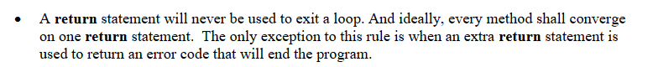

In the DonationLogImpl class, the isIdUnique method can look like (also note the parameter “id” was changed to lower case. Attributes never start with a capital letter)

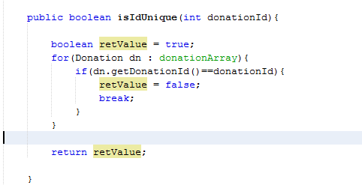

No deduction this week for coding standard issues, but will be enforced beginning next week,